Intensive peasant farming - Case Study: India
Practiced in areas of high population density in South East Asia such as India, Thailand and Malaysia, the typical farm size is 2.5 acres and the main crop is rice.
Little or no capital is available as this is a subsistence type of farming i.e. food is produced for personal consumption.

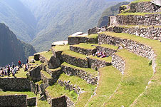
Land
Most farmers are tenants who must pay a proportion of their crops to a landlord. This is called share-cropping.
As rice is grown in flooded field. Wide, flat floodplains such as that of the River Ganges is ideal. However, much steeper land is terraced to provide additional growing space.

Climate
Minimum of 10 degrees Celsius is required for seeds to grow. Over 20 degrees is required for the rice to ripen. In some areas two or three crops a year are possible. High rainfall over 2000mm per year is essential for natural irrigation.

Technology
Little technology is used as many have no access to it or cannot afford it. Water buffalo are often used to pull ploughs.
Transport is not necessary either as the farmers produce only for their own consumption.

Fertiliser
Various methods are used to fertilise the soil. Animal and human manure is occasionally added, but it is not significant. Rice stubble is ploughed back into the fields to release nutrients, and the water added to the fields brings fertile silt, as do any river floods. Nitrogen fixing algae can also enrich the water and soil. Nutrients are also released from the underlying parent material.

Labour
A very high population density is required, as this type of farming is very labour intensive. All work is done by hand.

Socio-cultural
Small farms sizes are a result of inheritance practices which result in land being split between siblings, reducing the area available for each family

Shifting cultivation - Case study: the Amazon Basin
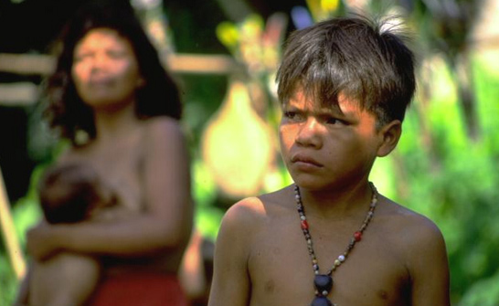
Learning Zone Scotland: the Yanomami people of the Amazon Basin.
Practiced in the Tropical Rainforests of the world, such as Amazonia, central Africa and south east Asia, where population density is low. It is a small-scale, primitive but sustainable (environmentally friendly) form of agriculture in which a small plot of land is used but a large area is required. A typical family unit of 20 people uses around 120 hectares.
The main crops are maize, manoic, yucca, yams and cassava. Yields are low and protein is added to the diet through hunting, gathering and fishing.
The group clear the trees using simple tools then burn the stumps that remain to add ash to the soil. This fertilises the soil. This technique is called slash-and-burn.
After two or three years the soil loses its fertility and crop yields fall, forcing the people to move to another plot. The vegetation normally recovers in about 30 years. This lifestyle supports around 300million people worldwide. The Yanomami or Boro tribe are typical shifting cultivators.
Little or no capital is available as this is a subsistence type of farming - food is produced for personal consumption. Government grants are available but they have little impact as few of the farmers even know who is in power.

Land
This varies depending on the size of the tribe. The overall area used is approximately 1,000 hectares (ha) per person.

Climate
High temperatures and high rainfall allow for a 12 month growing season, so there are always ripe crops available.

Socio-cultural
The tradition of sharing the land is important in preserving this way of life.

Technology
Little technology is used as many have no access to it or cannot afford it. Primitive digging sticks and axes are often used and the main form of transport is canoe.

Fertiliser
Ash is the only natural fertiliser used as the people do not keep animals that could be a source of manure.

Labour
The crops are tended mainly by women and children as the men supplement the basic diet through hunting, gathering and fishing.

Soils
Most nutrients in the Rainforests are held in the vegetation so the soils (latosols) are very poor, suffering heavy nutrient loss from the high rainfall, and rapid loss of fertility.

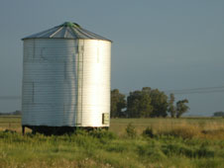
Extensive Commercial Farming - Case study: Great Plains of North America
Extensive commercial farming is found throughout the world in the Pampas of Argentina, the Russian Steppes, Australia and south east England. The most characteristic of this farming type though are the Great Plains of North America (Canada and USA).
Commercial farming depends on good transport and marketing organisation to distribute the produce. This type of agriculture involves the use of a small labour force, a high degree of mechanisation and a large farm - so it is capital intensive. Scientific and technological advances are used e.g chemicals. Water is regulated so that maximum yields are obtained without damaging the soil or lowering its fertility. Most of the produce, if not all, is sold for cash.

Land
Extensive areas of flat or gently undulating land is required. The soil must be deep and fertile, but can and is enhanced using fertilisers. The typical soil type is
a Chernozem which is black and humus rich, and good at conserving moisture and binding soil in the dry climate.
The crops are often grown in monoculture, meaning only one crop, and there is no need for fences to mark field boundaries.
Grain silos or elevators are a common feature of the landscape, where the grain is stored before transport.

Climate
Moderate temperatures and rainfall is required as the crops cannot withstand extremes of either. Long, sunny summer days help to ripen crops whilst winter snow helps to insulate the ground, allowing early planting. Intense winter frosts kill off pests and plant diseases, and break the soil into fine crumbs, making it easier to work.
In the USA warm winds from the Rocky Mountains (Chinook) rapidly melts the snow. There tends to be a six month growing season that varies depending on latitude.
Cattle-ranching is not so dependent on climatic conditions, which is why this occurs in the drier parts of these regions.

Technology
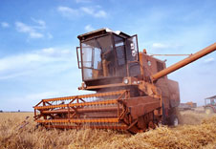
Technology in the form of machinery is used extensively. There is high investment, it is high tech and modern e.g. combine harvesters. Irrigation systems are also employed to cope with the frequent drought conditions in some regions.
Like the Green Revolution, seeds have been designed to be resistant to disease and drought, and to be faster growing (some fewer than 90 days).
Sophisticated transport networks are also required to ship produce to markets, and can be built cheaply and easily on the vast expanses of flat land.

Fertiliser
High levels of artificial fertiliser and pesticides are used e.g. nitrogen based fertilisers, and are often sprayed by aircraft.

Labour
Labour is a low priority input as machinery does the majority of work. Often labour is employed on seasonal contracts during harvesting, and this leads to outmigration and rural depopulation.

Government
Many government grants and subsidies are provided to support farmers in difficult times and to guarantee a price for produce. This disadvantages foreign producers.

