- Mog is having a nightmare and being chased by an evil bird!
- Mog wakes up in the early morning and smells burning.
- Mog gets scared and manages to call the fire brigade.
- Mog pulls all the nicely laid out food off the table.
- Mog jumps onto the fan, which starts spinning him around until he falls off.
- The Grandfather clock falls over and hits the electricity plug.
- The lights smash and everything falls of the Christmas tree!
- The oven opens and black smoke goes everywhere.
- Mog runs out of the kitchen through the cat-flap.
- The Fire Brigade turns up and follows Mog.
- The family go back into the ruined house.
- Their neighbours bring Christmas to the Thomas´ house and everybody had a nice Christmas.

Wire laid- table  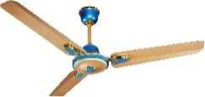  china f f fan  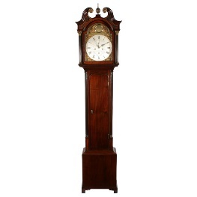  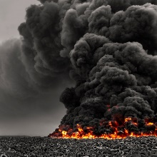  Grandfather clock  smoke cccccccccork  champagne bottle  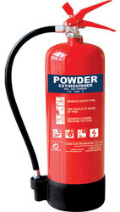  fire extinguisher  cremated/burned  Bauble | 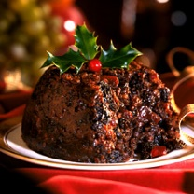  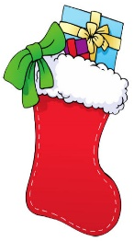  tear-jerker stocking  Christmas pudding  gift/present teddy bear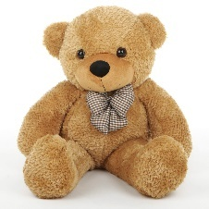  chocolate boxes  Department store  advert/advertisement  nightmare

