Christmas Vocabulary

Advent: the four-week season leading up to Christmas Day.
Boxing Day: the day after Christmas Day, 26th December.
Carol: a hymn that focuses on the Christmas celebration of Jesus’ birth.
Christmas cracker: a cardboard tube wrapped in coloured paper that opens with an explosive noise and releases a party toy, a paper hat and a joke when both its ends are pulled.
Christmas Day: 25th December.
Christmas Eve: the day before Christmas Day, 24th December.
Christmas pudding: a boiled pudding made of dried fruit and flavoured with cinnamon, ginger and brandy.
Congregation: a group of people brought together in a church.
Father Christmas: also known as Santa Claus, or Santa or visits houses on Christmas Eve.
Festive: an adjective used to describe a festival, normally joyous or merry.
Gravy: the fat and juices from the cooked meat that is often thickened and used as a sauce for meat.
Mince pie: a small round pie or tart containing sweet mincemeat (a mixture of currants, raisins, sugar and spices), typically eaten at Christmas.
Midnight Mass: a special late night service on Christmas Eve to celebrate the birth of Jesus and Christmas.
Mulled wine: red wine heated with sugar, spices and citrus fruit.
Nativity: the story of Jesus’ birth.
Pigs in blankets: sausages wrapped in bacon.
Stocking: a sock or sock-shaped bag, left out for Father Christmas to fill.
Stuffing: a mixture of seasoned breadcrumbs, onion, pepper and other herbs such as sage, either cooked separated or inside the turkey.
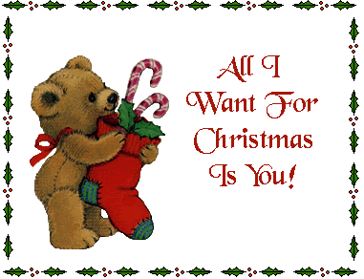
“All I Want For Christmas Is You”

I don't want a lot for Christmas
There is just one thing I need
I don't care about the presents
Underneath the Christmas tree
I just want you for my own
More than you could ever know
Make my wish come true
All I want for Christmas
Is you
I don't want a lot for Christmas
There is just one thing I need
And I don't care about the presents
Underneath the Christmas tree
I don't need to hang my stocking
There upon the fireplace
Santa Claus won't make me happy
With a toy on Christmas Day
I just want you for my own
More than you could ever know
Make my wish come true
All I want for Christmas is you
You baby
Oh I won't ask for much this Christmas
I won't even wish for snow
And I'm just gonna keep on waiting
Underneath the mistletoe
I won't make a list and send it
To the North Pole for Saint Nick
I won't even stay awake to
Hear those magic reindeer click

'Cause I just want you here tonight
Holding on to me so tight
What more can I do?
Baby all I want for Christmas is you
You, baby
Oh all the lights are shining
So brightly everywhere
And the sound of children's
Laughter fills the air
And everyone is singing
I hear those sleigh bells ringing
Santa won't you bring me the one I really need?
Won't you please bring my baby to me?
Oh I don't want a lot for Christmas
This is all I'm asking for
I just want to see my baby
Standing right outside my door
Oh I just want you for my own
More than you could ever know
Make my wish come true
Baby all I want for Christmas is
You baby
All I want for Christmas is you baby
All I want for Christmas is you baby
All I want for Christmas is you baby

